Step 1: Go to Retro Menu

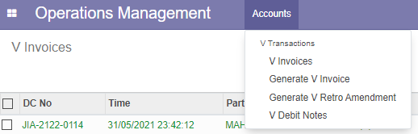

Step 2: select old invoice no.

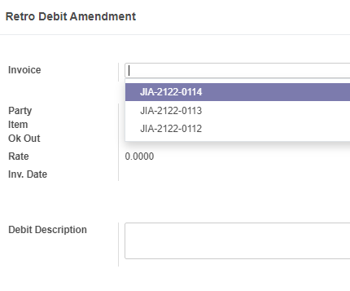

Step 3: Enter customer GR No

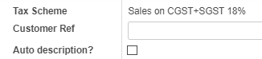

Use Auto description for automatic description. This is optional. Enter description and basic amount, then click Generate Debit Note.